BLOOD BANK
ABSTRACT
This project acts as an important role in saving life of human beings and which is also its main aim. The project Android Blood Bank system is developed so that users can view the information about registered blood donors such as name, address, and other such personal information along with their details of blood group and other medical information of donor. The project also has a login page where in the user is required to register and only then can view the availability of blood and may also register to donate blood if he/she wishes to. Thus, this application helps to select the right donor instantly using medical details along with the blood group. The main aim of developing this application is to reduce the time to a great extent that is spent in searching for the right donor and the availability of blood required. Thus, this application provides the required information in no time and also helps in quicker decision making.

SYSTEM SPECIFICATION
HARDWARE SPECFICATION:
- Processor : P 4 700 GHz.
- RAM : 2GB RAM
- Hard Disk Drive : 16 GB

SOFTWARE SPECIFICATION:

  - Operating System : Android
  - Front End : JAVA
  - Back End : ORACLE
EXISTING SYSTEM
Blood bank system normally used in when do we need a blood just contacts with friends, friends of friends or hospital. Which takes more time at an emergency time. Normally the donor has to went hospital and give their personal details then the hospital nurse and doctors has contact them. Which may not use at the emergency situation.
DISADVANTAGES
- Takes too much time for contact the donor
- Someone not attending the call
- can’t get updated details
PROPOSED SYSTEM
In this application is a mobile application, every user can have mobile so we just getting GPS location on every 5 minutes. So, we can track the latest donor location. Have an option for finding the nearby donors’ details so we can easily contact the nearby donor. It’s very helps to find the donor who are all willing to donate the blood.

ADVANTAGES
- Contact donor immediately
- Avoid fake donors
- very fast and secure mobile app

MODULES DESCRIPTION:
- Donor Registration
This module will be helps to handle for collecting the donor’s details, which is manually collect the donor’s details from the donors. The donors give their details like mobile number, email id, address details and current address etc. which is may be used to contact the donors at the emergency time.
2. Find donors
This module is a main module of this project, it could be finding the donors by as a blood group wise. When the user needs a blood, they just give a blood group name it will automatically find and give people list who are all having a same blood.
3. Find nearby donors
Basically, this module helps to collect the real time user location from the donors. When the emergency people need a blood from the nearby donors, it may give an accurate nearby donor.
4.Blood Request:
This module handles the request and response for the all the blood request, this can manage the relationship between blood donors.
5.Manage donor’s request
This module having lot of concept, it will be managing a sender and receiver donors communicate request. A sender sends a request to the donors a receiver can accept or reject the request. This is a basic concept of this module.

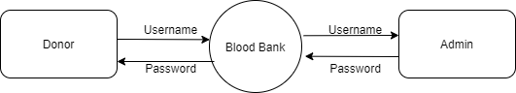
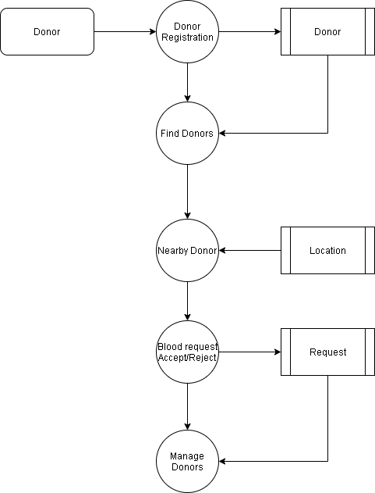

TABLE NAME: ADMIN
FIELD | DATA TYPE | SIZE | CONSTRAINT
Admin id | Int | 10 | Primary key
Username | Varchar | 20 | Not null
password | Varchar | 20 | Not null

TABLE NAME: DONOR
FIELD | DATA TYPE | SIZE | CONSTRAINT
Donor id | Int | 10 | Primary key
Name | Varchar | 20 | Not null
Age | Int | 10 | Not null
Blood group | Varchar | 2 | Not null
Mobile | Int | 10 | Not null
Donor username | Varchar | 20 | Not null
Donor password | Varchar | 20 | Not null
City | Varchar | 20 | Not null
District | Varchar | 20 | Not null
Pin code | Int | 6 | Not null
Address | Varchar | 20 | Not null

TABLE NAME: REQUEST
FIELD | DATA TYPE | SIZE | CONSTRAINT
Request id | Int | 10 | Primary key
Donor id | Int | 10 | Foreign key
Sending status | Varchar | 5 | Not null
Receiving status | Varchar | 5 | Not null
date | Date | 10 | Not null

TABLE NAME: LOCATION
FIELD | DATA TYPE | SIZE | CONSTRAINT
Location id | Int | 10 | Primary key
Donor id | Int | 10 | Foreign key
Latitude | Varchar | 10 | Not null
Longitude | Varchar | 10 | Not null
Last location | Varchar | 10 | Not null
Current location | Varchar | 10 | Not null

